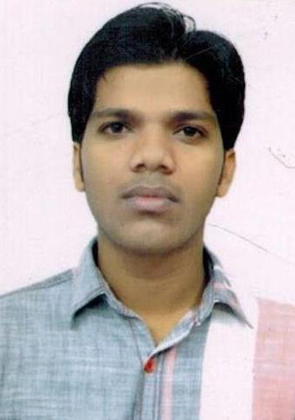
AJAY SINGH CHAUHAN
Mobile : +91-7898607096 E-Mail: Chauhan.ajaysingh439@gmail.com
Seeking a position to utilize my Managerial skills and Technical abilities in the Co-operate field that offers professional growth while being resourceful and flexible to obtain a challenging and productive role in the leading companies.

SYNOPSIS
- B.E. (Electronic & Communication) with 1+ years of experience in Thermal Power Plant.
- Well Organized, Self motivated and a Team Player .
- Enthusiastic and well-honed skills
- Will shoulder challenging work under Pressure
- Imbibed with patience and endurance
- Basic Knowledge of Computer
- Having Team building skills according to their skills and experience
- Quick Learner & and apply the concept in productive manner
CAREER HIGHLIGHTS

Oct’13 – Oct’14 Graduate Trainee MONNET ISPAT & ENERGY LTD., (RAIPUR)

TECHNICAL SKILL:

Primary Skills : Operational Maintenance, Radio Frequency related work
Operating Systems : Windows XP Professional, Window 7
Application : MS Office, Internet, Email

MAJOR PROJECTS HANDLED:

Title : GAT – Shift Incharge (Power C & I) at MONNET ISPAT & ENERGY LTD.
Tenure : Oct’13 – Oct’14
Tools/Technologies : PLC SCADA
Scope : MONNET ISPAT & ENERGY LTD., (RAIPUR) is a Thermal Power Plant of 60MW
with 6 division (Ferro, CHP, Power, Rolling Mill, SMS1, SMS2).
.

Role :
- Handling all TPP – Operational Maintenance – Shift activities which include Report generation, all maintenances & repairing works.
- Handling Manpower
- All Documentations & Database Management jobs for ISO & CDM Project Co- ordination.
- Inspection in field

PROJECTS & TRAINING

- Done 15 days Vocational Training at BSNL JABALPUR (M.P.) in Mobile Communication & Major Training from BSNL (SIDHI) in GSM System

- Done final year engineering project on “AUTOMATIC ROOM LIGHT CONTROLLER WITH VISITOR COUNTER”.

ACADEMIC ACHIEVEMENT

- Rewarded for excellent performance at school level in 12th
- Got 1st Prize in quiz competition in school Level.
- Got Scholarship in 10th class for achieving 7th position in Dist – Sidhi.

EDUCATION

COURSE | BOARD/UNIVERSITY | INSTITUTION | YEAR | PERCENTAGE
B.E. (Elec. & Comm.) | RGTU | RADHARAMAN INST. OF RESEARCH & TECHNOLOGY, Bhopal | 2012 | 73.41%
SENIOR SECONDARY | MPBSE | GOVT. HIGHER SECONDARY EXCELLENCE, SCHOOL No. 1, Sidhi | 2008 | 86.8%
HIGH SCHOOL | MPBSE | SARASWATI SHISHU MANDIR HIGHER SECONDARY SCHOOL, Sidhi | 2006 | 87.8%

EXTRA CURRICULAR ACTIVITES/HOBBIES

- Responsible member of Institution of Engineering & Technology, India ( 2008-2012)
- Playing Cricket, Gardening, Listening Music

PERSONAL DETAILS

Date of Birth : 13th June, 1991
Language Known : English, Hindi
Marital Status : Unmarried
Address : House No- 23, Vill – Jogipur, Dist - Sidhi.
Pin Code – 486661

Date Ajay Singh Chauhan

Place

